Asymmetric Zigzag Shapes
# Source: AI Source: Provided by: [Data Path: Persons Table -> ID Column: 1, Name_En Column: Motasem Essam] -> From: [ChatGPT] on [7/25/2026]
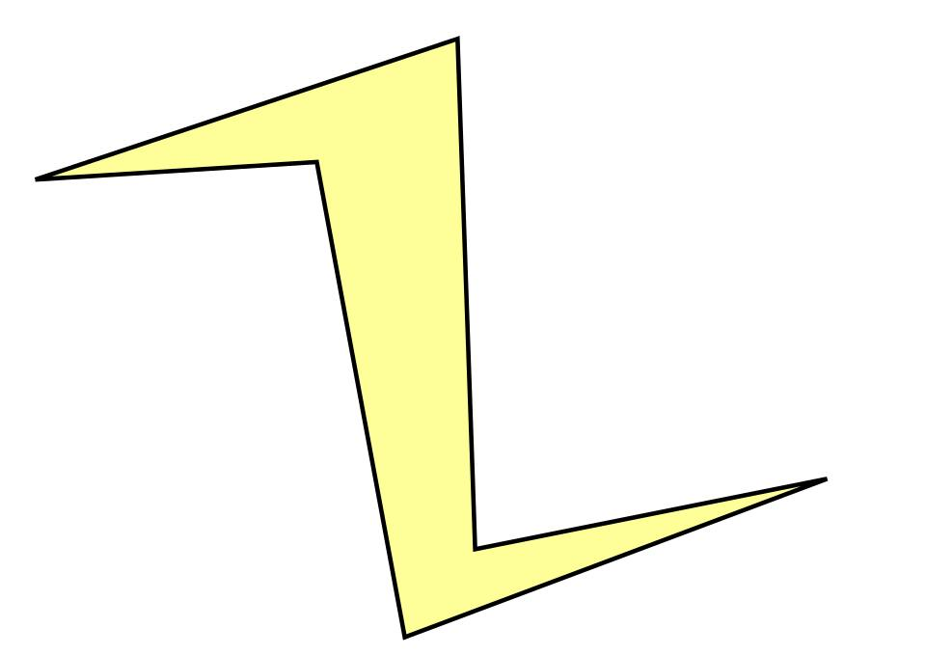
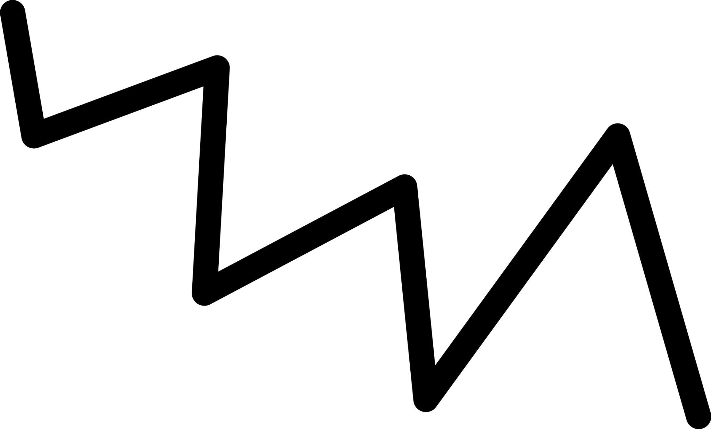
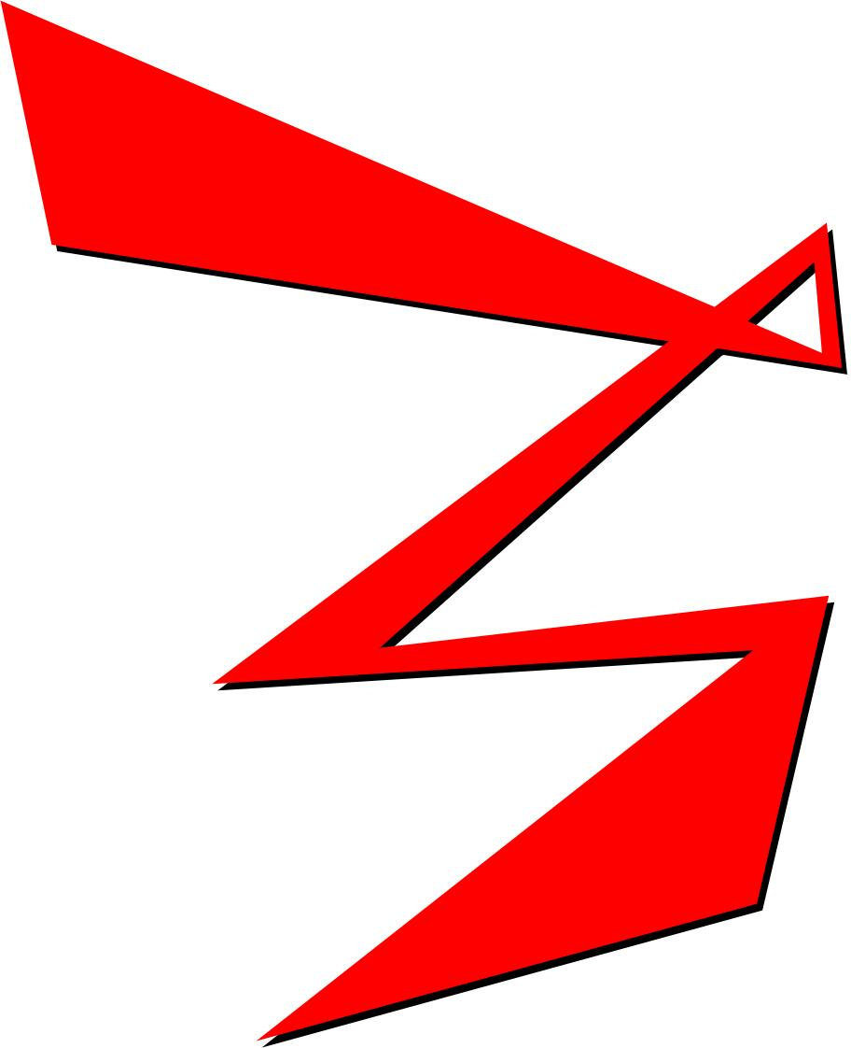
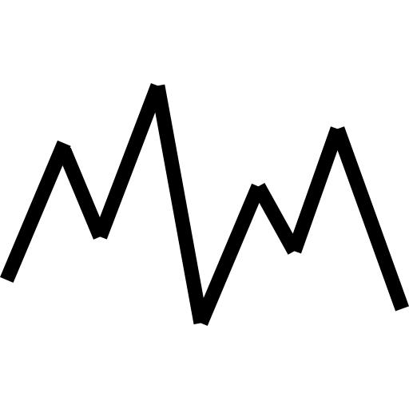
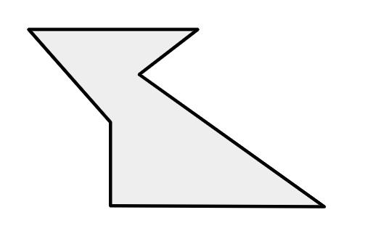
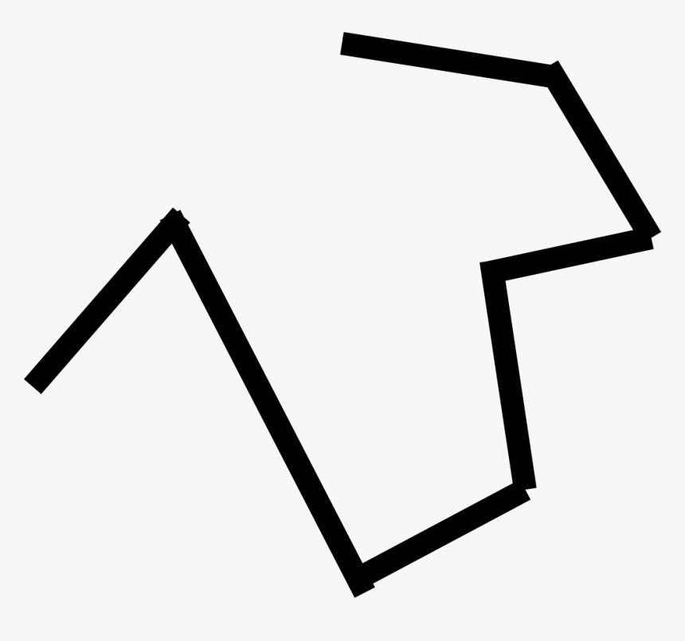

Definition
# Source: AI Source: Provided by: [Data Path: Persons Table -> ID Column: 1, Name_En Column: Motasem Essam] -> From: [ChatGPT] on [7/25/2026]
An Asymmetric Zigzag Shape is a zigzag shape that has no symmetry under the particular symmetry transformation being considered.
Its two sides, segments, angles, or overall arrangement do not correspond to each other through reflection, rotation, or point symmetry.
An asymmetric zigzag can be regular or irregular, and it can be open or closed.

Fundamental Concept
# Source: AI Source: Provided by: [Data Path: Persons Table -> ID Column: 1, Name_En Column: Motasem Essam] -> From: [ChatGPT] on [7/25/2026]
A zigzag is asymmetric when no transformation that is being considered maps the entire shape onto itself.
For example:
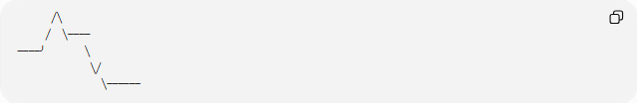
╱╲
╱ ╲────
────╯ ╲
╲╱
╲──────
The two sides do not form matching mirror patterns.
For a symmetry transformation $T$, an asymmetric shape does not satisfy:
$$\boxed{T\left(S\right)=S}$$
for the transformations under consideration.

Main Characteristics
# Source: AI Source: Provided by: [Data Path: Persons Table -> ID Column: 1, Name_En Column: Motasem Essam] -> From: [ChatGPT] on [7/25/2026]
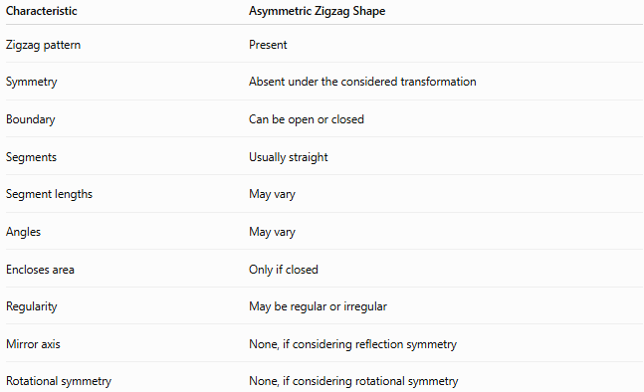
Characteristic | Asymmetric Zigzag Shape
Zigzag pattern | Present
Symmetry | Absent under the considered transformation
Boundary | Can be open or closed
Segments | Usually straight
Segment lengths | May vary
Angles | May vary
Encloses area | Only if closed
Regularity | May be regular or irregular
Mirror axis | None, if considering reflection symmetry
Rotational symmetry | None, if considering rotational symmetry

Types of Asymmetric Zigzag Shapes
# Source: AI Source: Provided by: [Data Path: Persons Table -> ID Column: 1, Name_En Column: Motasem Essam] -> From: [ChatGPT] on [7/25/2026]
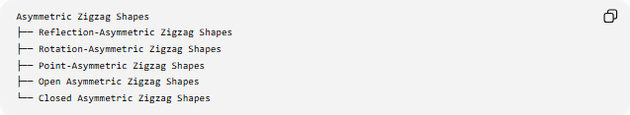
Asymmetric Zigzag Shapes
├── Reflection-Asymmetric Zigzag Shapes
├── Rotation-Asymmetric Zigzag Shapes
├── Point-Asymmetric Zigzag Shapes
├── Open Asymmetric Zigzag Shapes
└── Closed Asymmetric Zigzag Shapes

1-Reflection-Asymmetric Zigzag Shapes
# Source: AI Source: Provided by: [Data Path: Persons Table -> ID Column: 1, Name_En Column: Motasem Essam] -> From: [ChatGPT] on [7/25/2026]
A Reflection-Asymmetric Zigzag Shape has no line of reflection symmetry.
For example:
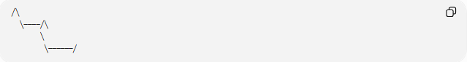
╱╲
╲────╱╲
╲
╲──────╱
Reflecting the shape across a potential axis does not reproduce the original shape.
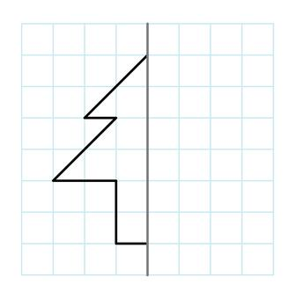
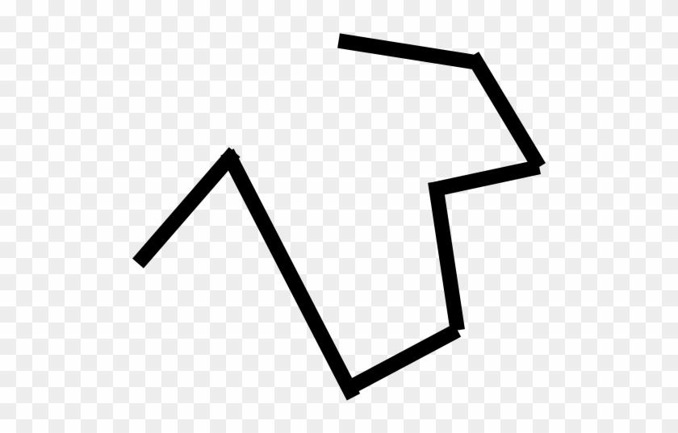

2-Rotation-Asymmetric Zigzag Shapes
# Source: AI Source: Provided by: [Data Path: Persons Table -> ID Column: 1, Name_En Column: Motasem Essam] -> From: [ChatGPT] on [7/25/2026]
A Rotation-Asymmetric Zigzag Shape does not map onto itself after a non-trivial rotation.
For example, rotating the shape by ${90}^{∘}$, ${120}^{∘}$, ${180}^{∘}$, or another relevant angle produces a different arrangement.

3-Point-Asymmetric Zigzag Shapes
# Source: AI Source: Provided by: [Data Path: Persons Table -> ID Column: 1, Name_En Column: Motasem Essam] -> From: [ChatGPT] on [7/25/2026]
A Point-Asymmetric Zigzag Shape does not have ${180}^{∘}$rotational symmetry about any point.
Thus, there is no center such that rotating the shape by ${180}^{∘}$reproduces it.

4-Open Asymmetric Zigzag Shapes
# Source: AI Source: Provided by: [Data Path: Persons Table -> ID Column: 1, Name_En Column: Motasem Essam] -> From: [ChatGPT] on [7/25/2026]
An Open Asymmetric Zigzag Shape has two endpoints and lacks the specified symmetry.
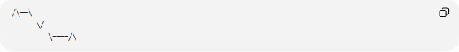
╱╲──╲
╲╱
╲────╱╲
The path does not close and does not exhibit the considered symmetry.
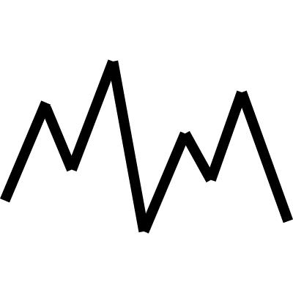
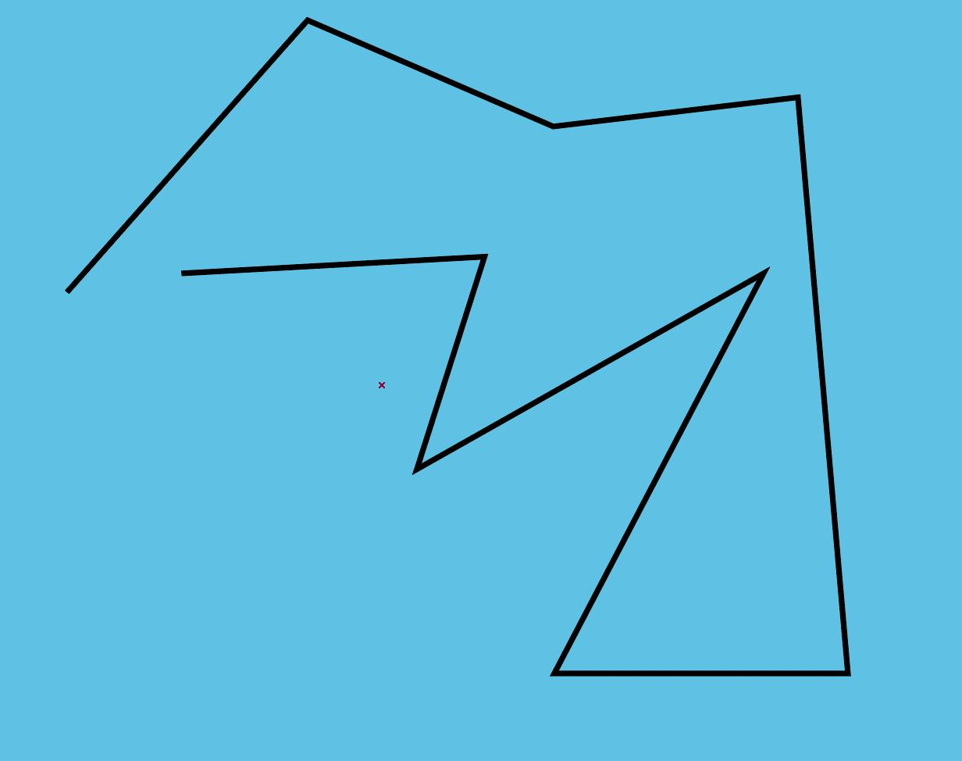

5-Closed Asymmetric Zigzag Shapes
# Source: AI Source: Provided by: [Data Path: Persons Table -> ID Column: 1, Name_En Column: Motasem Essam] -> From: [ChatGPT] on [7/25/2026]
A Closed Asymmetric Zigzag Shape forms a closed boundary but has no specified symmetry.
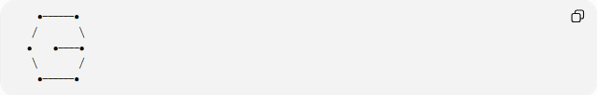
●──────●
╱ ╲
● ●────●
╲ ╱
●──────●
The boundary closes, but its arrangement is not symmetric.
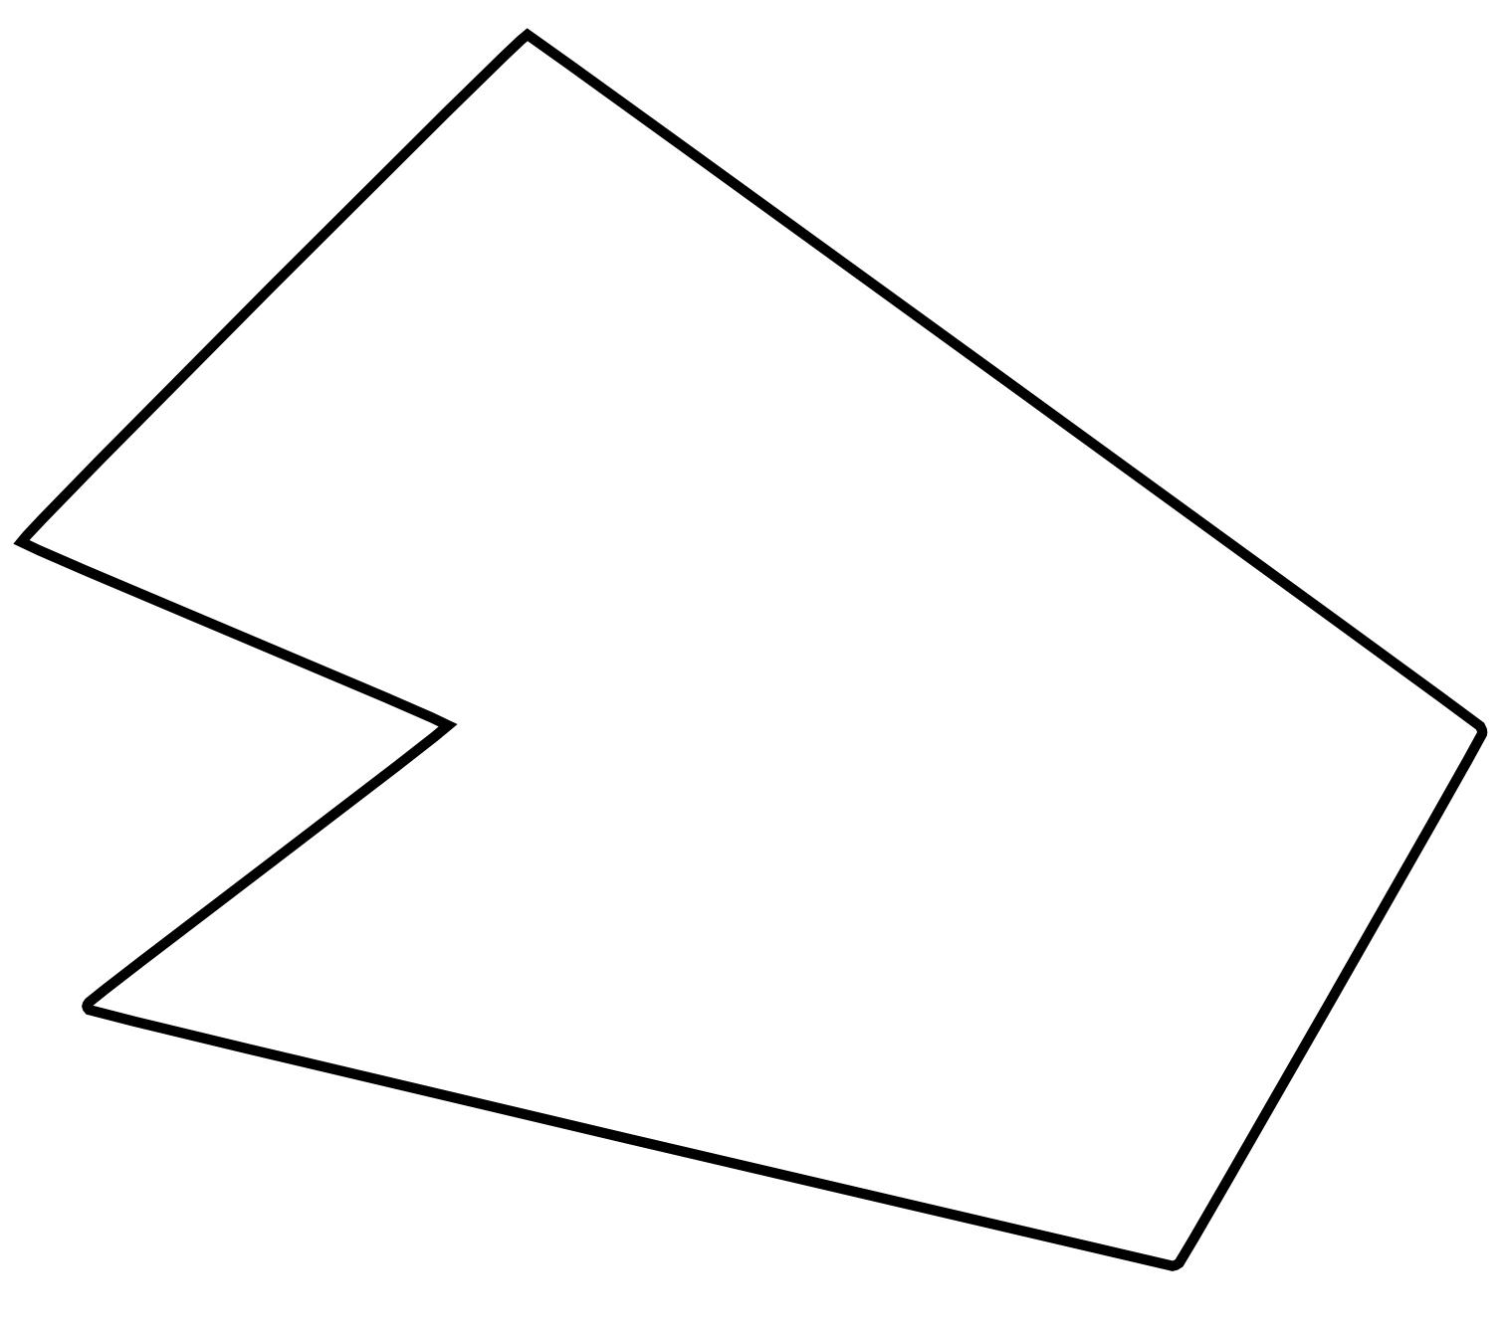
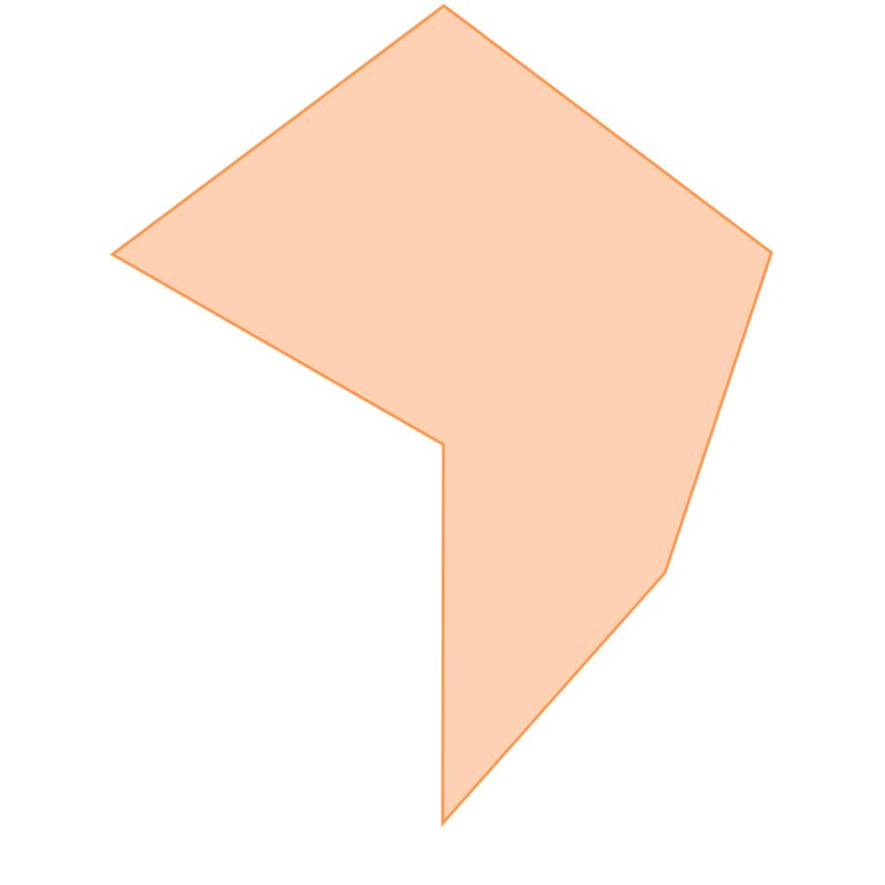
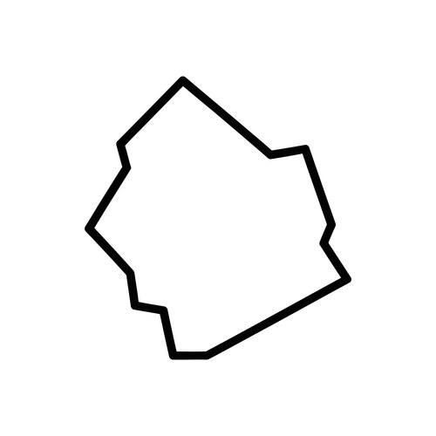

Asymmetric Zigzag and Regularity
# Source: AI Source: Provided by: [Data Path: Persons Table -> ID Column: 1, Name_En Column: Motasem Essam] -> From: [ChatGPT] on [7/25/2026]
Asymmetry and regularity describe different properties.
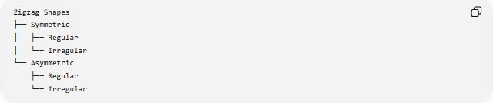
Zigzag Shapes
├── Symmetric
│ ├── Regular
│ └── Irregular
└── Asymmetric
├── Regular
└── Irregular
Therefore, a shape does not become asymmetric simply because its segments have different lengths.
Asymmetry specifically concerns symmetry.

Mathematical Properties
# Source: AI Source: Provided by: [Data Path: Persons Table -> ID Column: 1, Name_En Column: Motasem Essam] -> From: [ChatGPT] on [7/25/2026]
Reflection
For reflection across a vertical line $x=a$:
$$\left(x , y\right)→\left(2 , a-xy\right)$$
An asymmetric shape does not coincide with itself after such a reflection.
Rotation
For rotational symmetry of order $n$, the shape must reproduce itself after:
$$θ=\frac{{360}^{∘}}{n}$$
An asymmetric zigzag has no such non-trivial rotational symmetry.
Point Symmetry
Point symmetry is equivalent to ${180}^{∘}$rotational symmetry.
For a center $\left(h , k\right)$:
$$\left(x , y\right)→\left(2 , h-x 2k-y\right)$$
An asymmetric zigzag has no point that produces the same shape under this transformation.

Asymmetric vs. Symmetric Zigzag Shapes
# Source: AI Source: Provided by: [Data Path: Persons Table -> ID Column: 1, Name_En Column: Motasem Essam] -> From: [ChatGPT] on [7/25/2026]
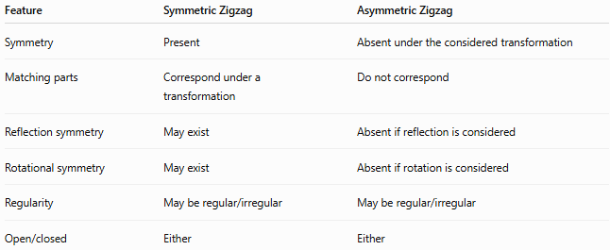
Feature | Symmetric Zigzag | Asymmetric Zigzag
Symmetry | Present | Absent under the considered transformation
Matching parts | Correspond under a transformation | Do not correspond
Reflection symmetry | May exist | Absent if reflection is considered
Rotational symmetry | May exist | Absent if rotation is considered
Regularity | May be regular/irregular | May be regular/irregular
Open/closed | Either | Either
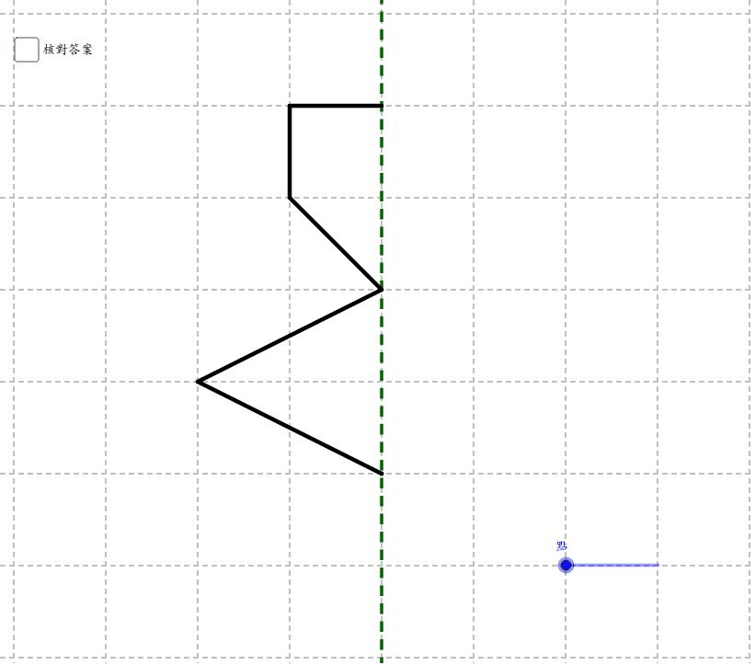
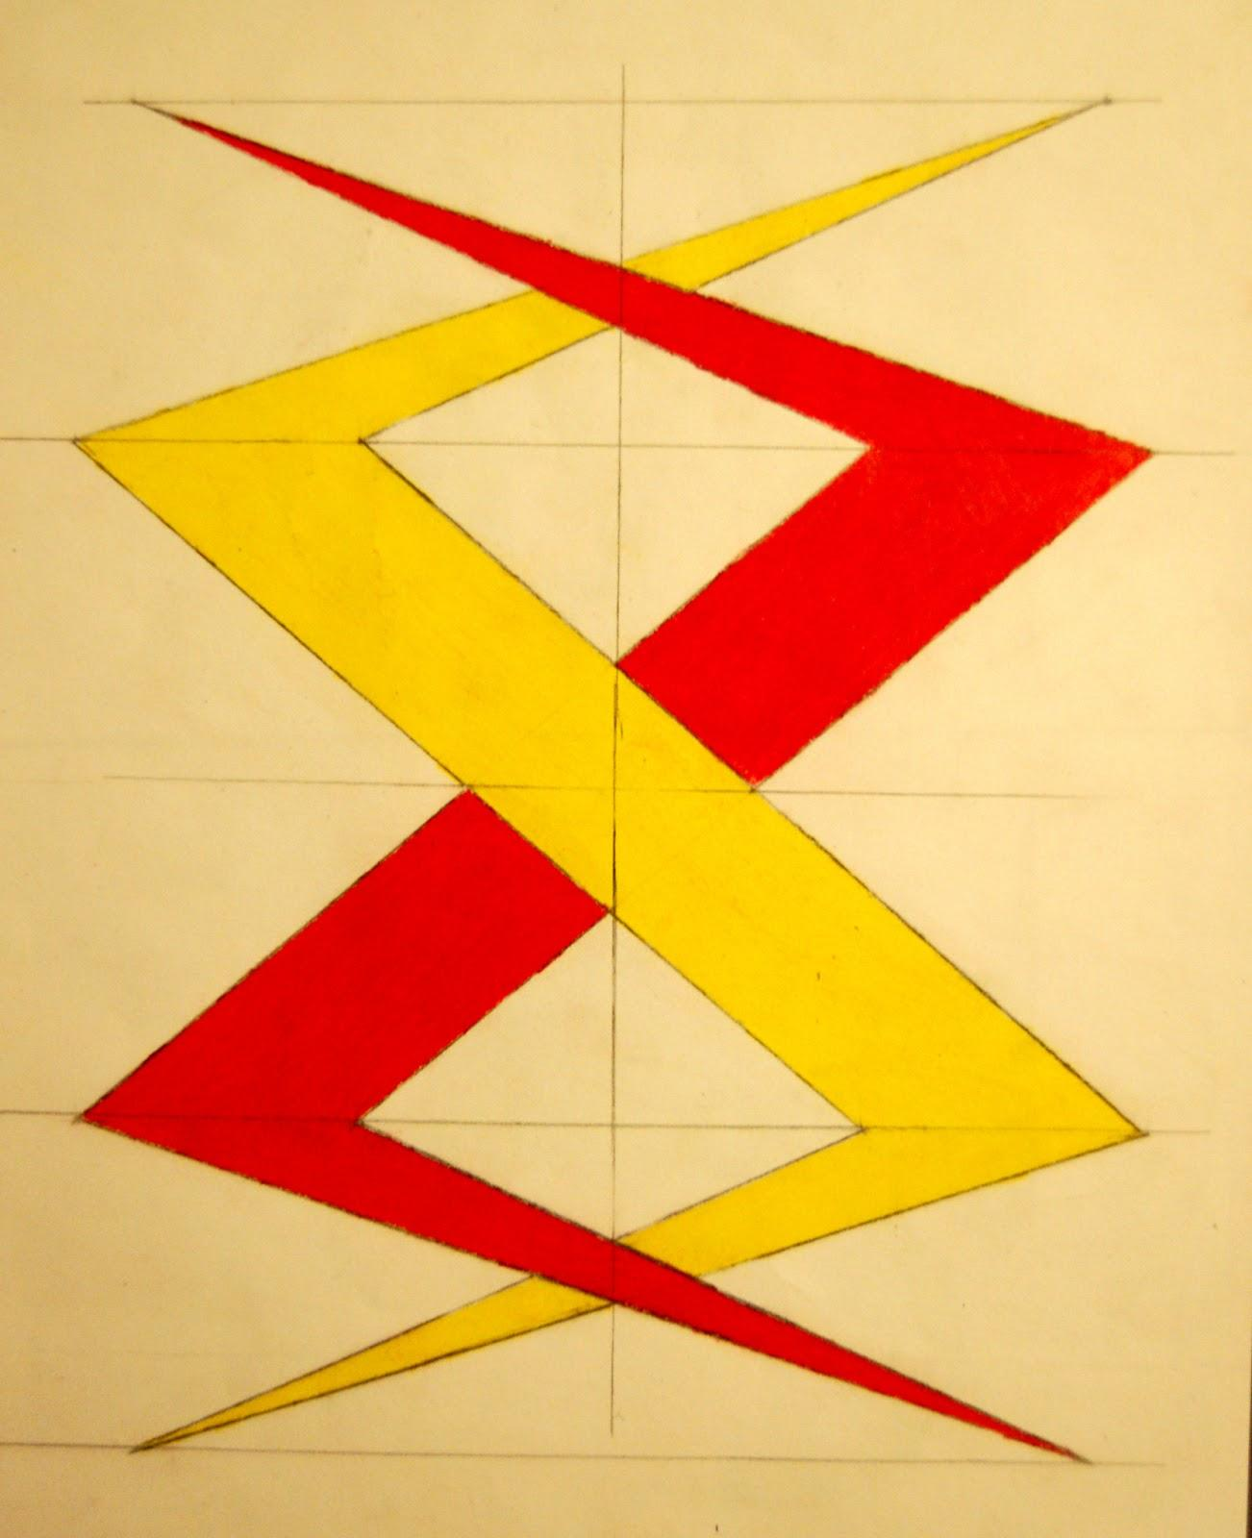
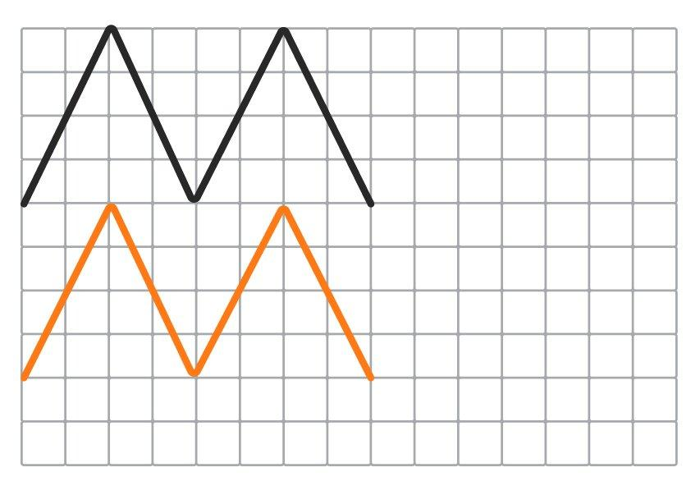

Asymmetric vs. Irregular Zigzag Shapes
# Source: AI Source: Provided by: [Data Path: Persons Table -> ID Column: 1, Name_En Column: Motasem Essam] -> From: [ChatGPT] on [7/25/2026]
These are not the same classification.
- Asymmetric → describes the absence of symmetry.
- Irregular → describes the absence of a consistent regular pattern.
For example, an irregular zigzag can still have reflection symmetry:
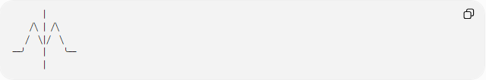
│
╱╲ │ ╱╲
╱ ╲│╱ ╲
──╯ │ ╰──
│
Therefore:
$$\boxed{\text{Asymmetric}≠\text{Irregular}}$$
A shape may be:
- regular and asymmetric,
- irregular and asymmetric,
- irregular and symmetric.

Examples

Example 1 – Asymmetric Open Zigzag
# Source: AI Source: Provided by: [Data Path: Persons Table -> ID Column: 1, Name_En Column: Motasem Essam] -> From: [ChatGPT] on [7/25/2026]
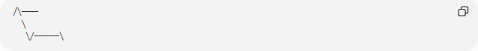
╱╲────
╲
╲╱──────╲
The path is open and has no reflection symmetry.

Example 2 – Asymmetric Closed Zigzag
# Source: AI Source: Provided by: [Data Path: Persons Table -> ID Column: 1, Name_En Column: Motasem Essam] -> From: [ChatGPT] on [7/25/2026]
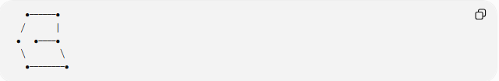
●──────●
╱ │
● ●────●
╲ ╲
●────────●
The boundary is closed but its arrangement lacks the considered symmetry.

Example 3 – Irregular and Asymmetric
# Source: AI Source: Provided by: [Data Path: Persons Table -> ID Column: 1, Name_En Column: Motasem Essam] -> From: [ChatGPT] on [7/25/2026]
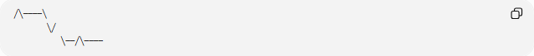
╱╲────╲
╲╱
╲──╱╲────
Both the geometric pattern and symmetry are non-uniform.

Classification Summary
# Source: AI Source: Provided by: [Data Path: Persons Table -> ID Column: 1, Name_En Column: Motasem Essam] -> From: [ChatGPT] on [7/25/2026]
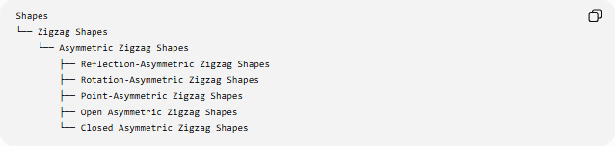
Shapes
└── Zigzag Shapes
└── Asymmetric Zigzag Shapes
├── Reflection-Asymmetric Zigzag Shapes
├── Rotation-Asymmetric Zigzag Shapes
├── Point-Asymmetric Zigzag Shapes
├── Open Asymmetric Zigzag Shapes
└── Closed Asymmetric Zigzag Shapes
Asymmetry can overlap with other zigzag classifications:
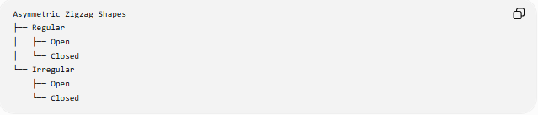
Asymmetric Zigzag Shapes
├── Regular
│ ├── Open
│ └── Closed
└── Irregular
├── Open
└── Closed

Key Points
# Source: AI Source: Provided by: [Data Path: Persons Table -> ID Column: 1, Name_En Column: Motasem Essam] -> From: [ChatGPT] on [7/25/2026]
- An Asymmetric Zigzag Shape lacks the specified symmetry.
- It may lack reflection symmetry, rotational symmetry, or point symmetry.
- It can be open or closed.
- It can be regular or irregular.
- Asymmetry and irregularity are different concepts.
- A closed asymmetric zigzag can form an asymmetric polygon.
- The absence of one type of symmetry does not automatically mean the absence of every possible symmetry unless all relevant transformations have been considered.

Conclusion
# Source: AI Source: Provided by: [Data Path: Persons Table -> ID Column: 1, Name_En Column: Motasem Essam] -> From: [ChatGPT] on [7/25/2026]
An Asymmetric Zigzag Shape is a zigzag whose arrangement does not reproduce itself under the symmetry transformation being considered. Its asymmetry is independent of its regularity, openness, or closedness, allowing it to occur in many different forms.

